Nama : M. Faris Daffarindra

NIM : F1E324003

Prodi : Informatika

**Lab 12**

1. The human body has many organs (heart, lungs, brain, and kidneys, to name a few). We could think of the human body as a complex object made up of simpler objects (organs).

(a) Create classes for heart and brain. Think about what the functions of the heart and brain are in our body and map these functions into methods.

(b) Create an Organ class as the base class for the organs and derive the classes created earlier from the base class.

Jawaban:

1. 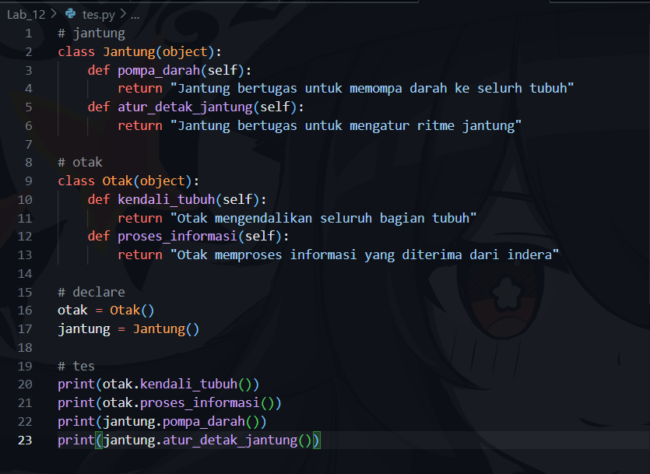
2. 